[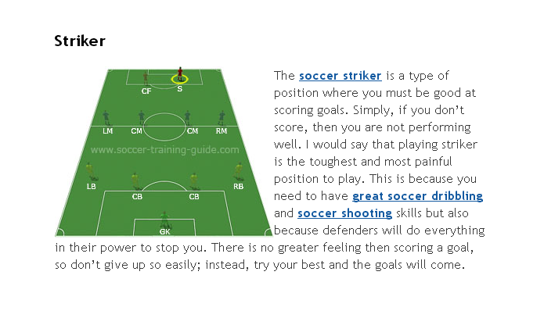](http://www.soccer-training-guide.com/soccer-striker.html#.UyJxGT9dXTo)

[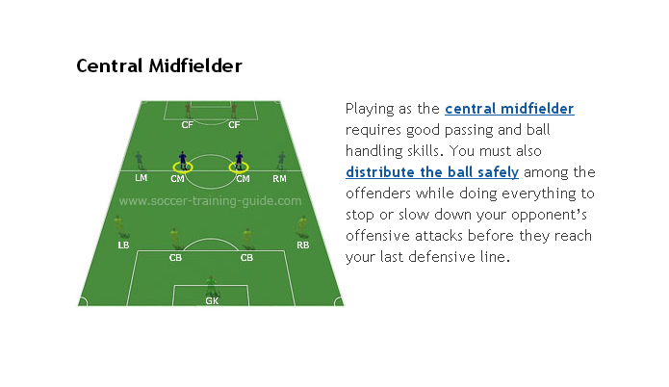](http://www.soccer-training-guide.com/central-midfielder.html#.UyJxaj9dXTo)[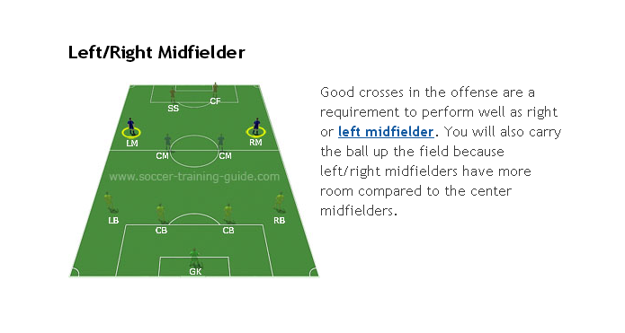](http://www.soccer-training-guide.com/left-midfielder.html#.UyJxUD9dXTo)

[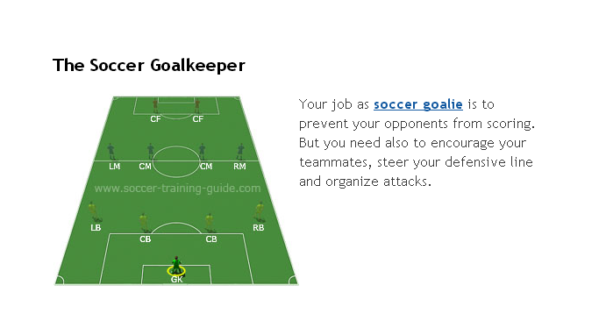](http://www.soccer-training-guide.com/soccer-goalie.html#.UyJxtD9dXTo)[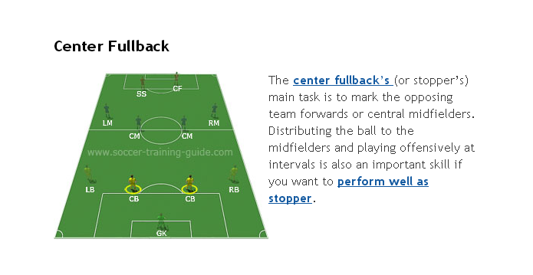](http://www.soccer-training-guide.com/playing-fullback.html#.UyJxjj9dXTo)